Annex 8

Field Survey Record Form (Example)

Constructor:
Construction location:
I. Location and schematic diagram (unit: m)
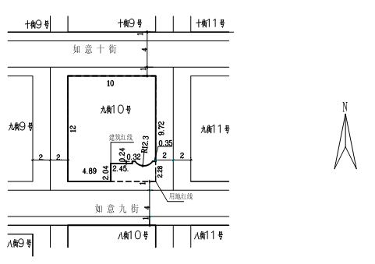

II. Four-direction boundaries in detail
1. Project (construction site) Built Partially built Not built Existing house reconstruction
2. Surrounding roads
Surrounding roads | Position | Road name | Current road width | Road width restrictions | Distance from project boundary to roadside | Remarks
 | East
 | South
 | West
 | North
3. The river (stream) adjacent to the project (construction site) is ___ meters away from the river (stream) side, the river (stream) is ___ meters wide, and the no-construction zone of flood protection dike extends _____ meters;
Water conservancy department Agree Disagree.
4. The high-voltage line of the project (construction site) is _____ volt, _____ meters away from the high-voltage sideline;
Power supply department Agree Disagree.
5. Distance between the crown edge of the famous ancient tree and the project (construction site): ___ meters.
6. Distance between the cultural relics or historical buildings and the project (construction site): ___ meters.
7. Four-direction boundaries are inconsistent with the land certificate; The land type is inconsistent; Mistakes and omissions in land certificate registration;
8. Buildings beyond the four-direction boundaries
 | East | South | West | North
Number of floors
Spacing
Setback of self-use land boundary
Purpose
Field surveyor:
Date:

